**Input devices**

**Name class**

1. Write down some example about each of the following input device.

A pointing devices:

____________________________________________________________________

B Image capture device:

____________________________________________________________________

C Sound and music capture device:

____________________________________________________________________

1. Describe the input devices used at an ATM machine.

____________________________________________________________________

____________________________________________________________________

____________________________________________________________________

1. Give two ways in which words can be input to a computer without using a keyboard

____________________________________________________________________

____________________________________________________________________

____________________________________________________________________

1. Name the data input type and the associated reader used to input the following characters and patterns into a computer

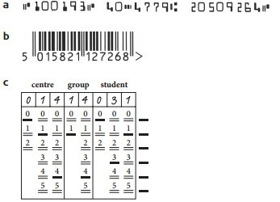

a ____________________________________________________________________

b

____________________________________________________________________

c ____________________________________________________________________

1. The majority of mobile phones use touch screens. Three common technologies are used by different mobile phone manufacturers.

Choose one of the following mobile phone technologies:

• resistive

• capacitive

Chosen technology______________________________

**(i)** Describe how your chosen technology works to allow a user to make selections by touching the screen.

____________________________________________________________________

____________________________________________________________________

____________________________________________________________________

____________________________________________________________________

____________________________________________________________________

____________________________________________________________________

____________________________________________________________________

**(ii)** Give **one** benefit and **one** drawback of your chosen technology when used on mobile phone touch screens.

Benefit

____________________________________________________________________

____________________________________________________________________

____________________________________________________________________

Drawback

____________________________________________________________________

____________________________________________________________________

____________________________________________________________________